Hardware Accomplishment Summary
for the
ACMEY Company Avionics Passenger Counter

Document No: 800-HAS-01
Revision: 0.1

__________________________________________________ |  |  | ___________
Project Manager |  | Date
__________________________________________________ |  | ___________
Technical Project Lead |  | Date
__________________________________________________ |  | ___________
Principal Design Engineer |  | Date
__________________________________________________ |  | ___________
Principal Quality Engineer |  | Date

Notice
This document and the information contained herein are the property of Airworthiness Certification Services LLC. Any reproduction, disclosure or use thereof is prohibited except as authorized in writing by Airworthiness Certification Services LLC. Recipient accepts the responsibility for maintaining the confidentiality of the contents of this document.

REVISIONS
Rev. | Reason/Description | Requested/ Changed By | Date
0.1 | Initial Draft | N/A

Table of Contents

Section Page
1.0 INTRODUCTION 5
1.1 Purpose 5
1.2 Scope 5
1.3 Part Number and Nomenclature 6
1.4 Team Members 6
1.5 Acronyms and Abbreviations 7
1.6 Applicable Documents 8
1.6.1 External Documents 8
1.6.2 Internal Documents 8
2.0 SYSTEM OVERVIEW 9
2.1 System Functional Description 9
2.2 System Architecture 9
3.0 HARDWARE OVERVIEW 10
3.1 Hardware Functions 10
3.2 Hardware Architecture 10
3.2.1 Computation 11
3.2.2 Entry/Exit sensor 12
3.2.3 Keypad Entry Panel 12
3.2.4 Display Panel 12
3.2.5 PIC Controller Interface & Fault Monitoring 13
3.2.5.1 PIC Controller & ARINC 429 FPGA Interface 14
3.3 Hardware Safety and Partitioning 15
4.0 CERTIFICATION BASIS AND SAFETY CONSIDERATIONS 16
4.1 Certification Basis 17
4.1.1 Hardware Design Assurance Levels 17
5.0 HARDWARE DESIGN LIFECYCLE 18
5.1 Hardware Validation and Verification Process 18
5.2 Hardware Configuration Management Process 20
5.2.1 Process Objectives and Activities 20
5.2.2 Technical Interfaces 20
5.2.3 Transition Criteria 20
5.3 Process Assurance Process 21
5.3.1 Process Objectives and Activities 21
5.3.2 Technical Interfaces 22
5.3.3 Transition Criteria 22
5.3.4 Project Reviews 22
5.4 Certification Liaison Process 23
5.4.1 Process Objectives and Activities 23
5.4.2 Technical Interfaces 23
6.0 HARDWARE DESIGN LIFECYCLE DATA 24
6.1 Hardware Lifecycle Data Produced and Controlled 24
7.0 PREVIOUSLY DEVELOPED HARDWARE 28
7.1 ARINC 429 I/O FPGA 28
7.1.1 ARINC 429 I/O FPGA Re-verification 28
8.0 ADDITIONAL CONSIDERATIONS 29
8.1 Use of Commercial-Off-The-Shelf (COTS) Components 29
8.2 SH-1 Issue paper compliance 29
8.2.1 Modifiable Devices 29
8.2.2 Certification Plan 29
8.2.3 Validation Processes 29
8.2.4 Verification Processes 29
8.2.5 Traceability 29
8.2.6 Configuration Management 30
8.2.7 Tool Assessment & Qualification 30
8.2.8 Simple Electronic Hardware (SEH) 30
8.2.9 Legacy Airborne Systems & Equipment Electronic Hardware 30
8.2.10 Commercial Off-The-Shelf (COTS) Microprocessors 30
8.2.11 Random Access Memory (RAM) based FPGAs 30
8.3 Development & Verification Tools 31
9.0 ALTERNATIVE METHODS 32
10.0 CERTIFICATION 33
6.2 Stage Of Involvement Summary (SOIs) 33
11.0 HARDWARE IDENTIFICATION 34
11.1 Part Number Identification 34
12.0 CHANGE HISTORY 35
12.1 Hardware Change History 35
13.0 HARDWARE STATUS- Open PRs 36
14.0 Compliance Statement 37
14.1 Statement of Compliance with the PHAC 37

INTRODUCTION

The ACMEY Passenger Counter System II S800-1000-01 is a new product based on the Legacy Passenger Counter System S800-1000-00. The Passenger Counter System II is updating the processor circuit card assembly with a new PIC microprocessor, Xlinix FPGA, and expanded functionality. The Legacy Passenger Counter II was a design assurance level (DAL) C product. The new Passenger Counter II will be developed to DAL B to accommodate future development for airline dispatch for total passenger count as a primary source which is a DAL B function.

Purpose
This Hardware Accomplishment Summary (HAS) applies to the ACMEY Passenger Counter II system, Part No S800-1000-01. The HAS describes how ACMEY CO. has complied to the Plan for Hardware Aspects of Certification (PHAC and demonstrates that the objectives of the of RTCA/DO-254, AC 20-152 and FAA SH-1 issue paper have been achieved for the complex electronic hardware devices.

Scope

It is the intent of this plan to describe the planning that has been completed and created the DO-254 compliant life cycle data needed to support the design approval of the Level A passenger counter FPGA.

Part Number and Nomenclature
Part Number | Nomenclature
S800-1000-01 | Avionics Passenger Counter
C800-1001-01 | Passenger Counter FPGA, 8 Bit Counter
C800-1010-00 | ARINC 429 I/o FPGA

Team Members
Name | Title
 | Project Manager
 | Systems Integration and Test
 | Reliability & Safety Engineer
 | Hardware Engineer
 | Hardware Configuration Management Engineer
 | Hardware Quality Assurance Engineer
 | FAA Designated Engineering Representative

Acronyms and Abbreviations

AIMS Action Item Management System
ALU Arithmetic Logic Unit
ARP Aerospace Recommended Practice
ASIC Application Specific Integrated Circuit
DRMS Document Review Management System
HC1 Hardware Control Category 1
HC2 Hardware Control Category 2
COTS Commercial-Off-The-Shelf
EUROCAE European Organization for Civil Aviation Equipment
FAR Federal Aviation Regulations
FFP Functional Failure Path
FFPA Functional Failure Path Analysis
FHA Functional Hazard Assessment
F-FMEA Functional Failure Modes and Effects Analysis
FTA Fault Tree Analysis
HDL Hardware Description Language
JAR Joint Aviation Requirements
LRU Line Replaceable Unit
PHAC Plan for Hardware Aspects of Certification
PLD Programmable Logic Device
PSSA Preliminary System Safety Assessment
RTMS Requirements Traceability Management System
SAE Society of Automotive Engineers
SC Special Committee
SSA System Safety Assessment
WG Working Group

Applicable Documents
The following documents are listed for reference only. Each document is applicable to this plan only to the extent specified herein.

External Documents
RTCA/DO-254 Design Assurance for Airborne Electronic Hardware

FAA Order 8110.4C Type Certification

FAA Order 8110.105 FAA, Simple and Complex Electronic Hardware Approval Guidance

AC 20-152 Advisory Circular, RTCA Inc., Document DO-254, Design Assurance for Airborne Electronic Hardware

Internal Documents

See tables 6-1 and 6-2 in this document for a full list of documents and their revisions.

SYSTEM OVERVIEW

System Functional Description

The Avionics Passenger Counter is a module that will keep track of how many passengers are currently in the aircraft/cabin. The current number of passengers in the cabin will be displayed on a display panel in real-time. The system will have a keypad entry so that the flight attendant can enter a passenger headcount correction/adjustment. The passenger headcount and any fault status information collected will be transmitted via ARINC 429 via the PIC processor and ARINC 429 I/O FPGA.

System Architecture

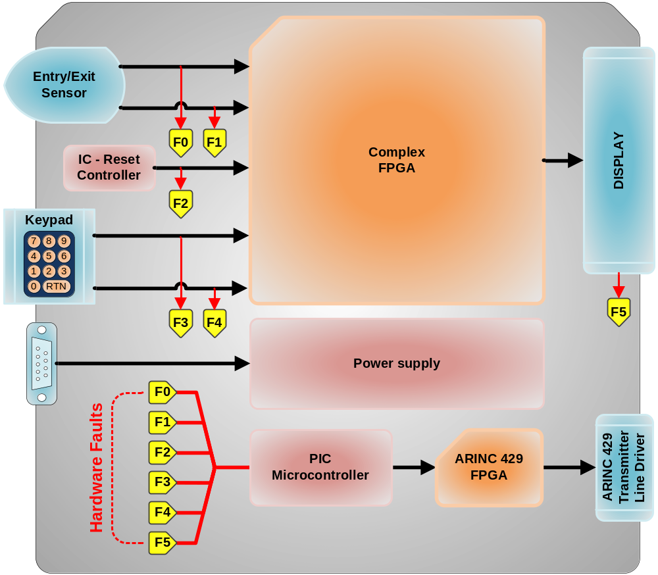

The passenger headcount function is performed by counting the number of entries and exits. The module uses an Entry/Exit-Sensor to detect passengers’ movements in and out of the cabin. The number of passengers in the cabin is tracked by an up/down counter in an FPGA. The passenger load is displayed in real-time on the display panel. The keypad entry can asynchronously load the counter thereby adjusting/correcting the passenger load on the display/system.

HARDWARE OVERVIEW
This section describes the hardware functions, hardware items, architecture, new technologies to be used, and any fail-safe, fault tolerant redundancy and partitioning techniques to be used.

3.1 Hardware Functions

There are five main hardware functions:

- Computation (Derived)
- Entry/Exit Detection
- Keypad entry
- Display
- Fault monitoring and ARINC 429 data transmit

3.2 Hardware Architecture

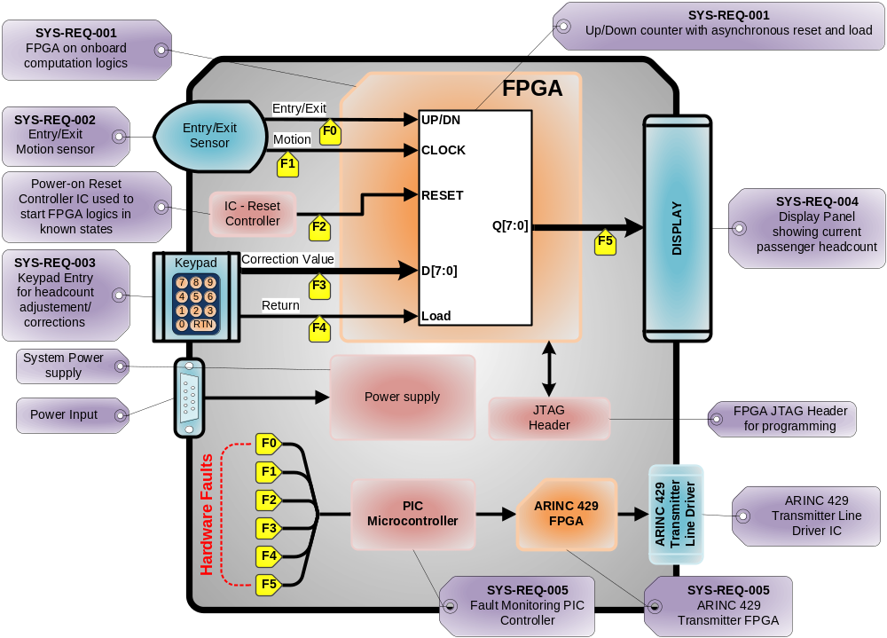

3.2.1 Computation

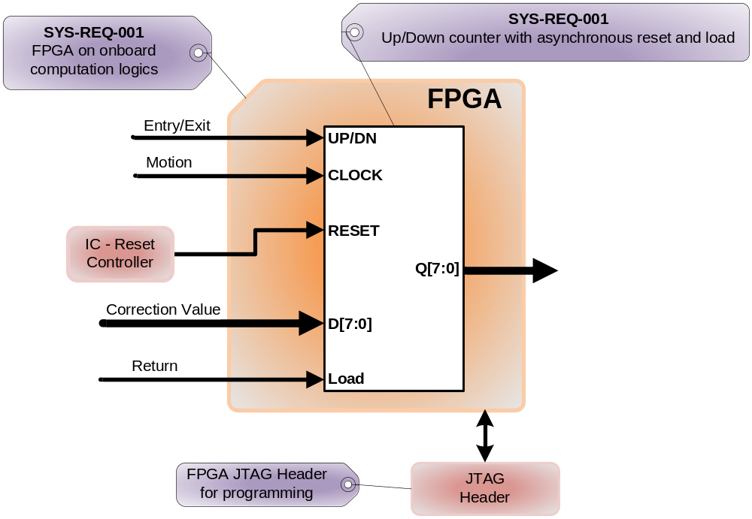

The headcount function is done by an up/down counter inside the FPGA. Every time the Entry/Exit motion sensor detects an entry or an exit, the counter increments or decrements accordingly. Ever time the user presses return, the current headcount output is loaded with previously typed value. The truth table is shown below.

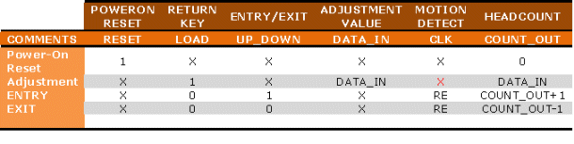

3.2.2 Entry/Exit sensor

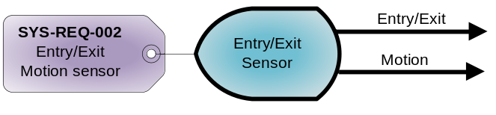
The Entry/Exit Detection function is performed by the Entry/Exit sensor. This sensor will detect human motion and decipher whether the motion is inward or outward. The information is then sent to the FPGA for headcount computation.

3.2.3 Keypad Entry Panel

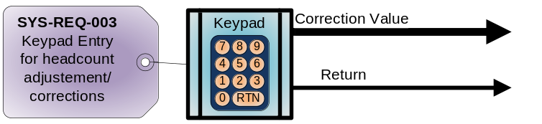

The headcount adjustment/correction data is generated by the keypad entry panel. This panel puts out a value typed by the user as well as a return key strobe signal. Both signals are sent to the FPGA for headcount adjustment/correction. The return key strobe signal is used to latch the value typed by the user into the FPGA logics.

3.2.4 Display Panel

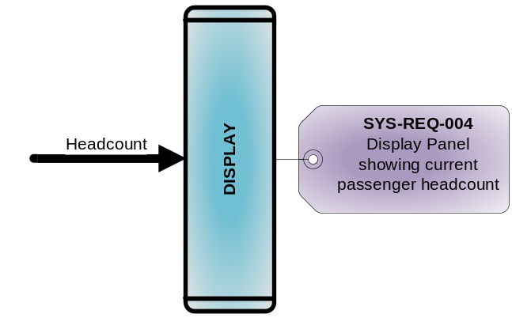
The display panel simply displays the current headcount outputted by the FPGA.

3.2.5 PIC Controller Interface & Fault Monitoring

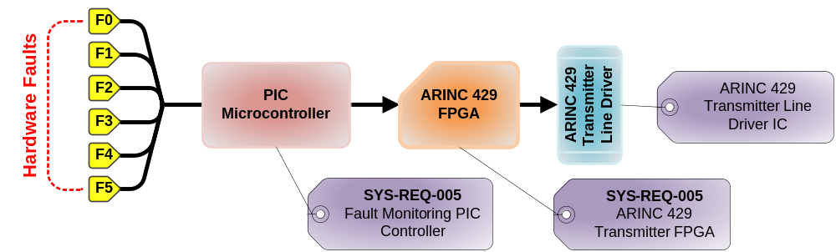

The Fault monitoring circuit monitors the sequences, timings and states of the Entry / Exit Detection sensor, Reset controller, keypad entry and the display panel. All of this information is fed to and analyzed by the PIC microcontroller. The PIC microcontroller’s software knows all the correct signal sequences, timing & states for all the interfaces. A fault is detected when a signal set is not within the predetermined constraints. The PIC controller then generates a fault message in the form able to fit into two 429 words which are sent to the FPGA. The FPGA then generates the appropriate serial ARINC 429 streams to the line driver which translates it out into the appropriate ARINC 429 signal level. The fault message is then sent to the maintenance computer via the ARINC 429 link. The cockpit multifunction display is used in maintenance aspects of the system. This is not a critical function and is used for maintenance and information only in the cockpit. The display reader provides the current passenger headcount to the flight attendant as the critical record for total headcount.

3.2.5.1 PIC Controller & ARINC 429 FPGA Interface

The ARINC 429 FPGA is connected to the PIC Microcontroller via a standard 8-bit bus interface. There are 8-bit data, 8-bit address and a chip-select (CE) line. There is also one GPIO that is used as an input to the PIC Microcontroller to indicate when the ARINC 429 FPGA is busy / sending data.

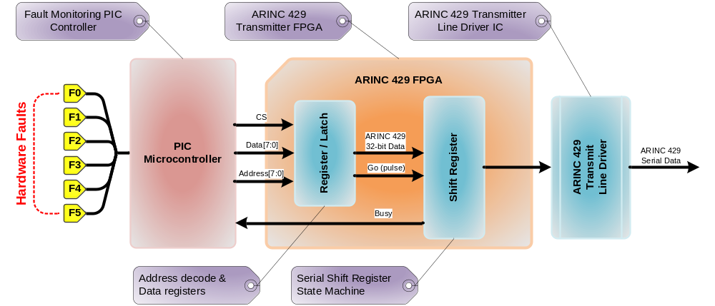

The ARINC 429 FPGA has to internal blocks: the Latch and the Shift Register. The Latch contains four 8-bit register that the Microcontroller can write to: each representing ¼ of the full ARINC 429 packet. These four register are made available to the next block in the form of a complete 32-bit bus/register to be loaded to the shift register. The Latch also contains a dummy register which, when written to, will send short pulse to the Shift Register. This short pulse will trigger the next block, the Shift register to load the data and serially shift out the data in the appropriate ARINC 429 format.

The final block in the ARINC 429 FPGA is the Shift Register. This block is really combination of a state machine and a shift register (shown in the figure below). The sole purpose of this block is to serially shift the 32-bit ARINC 429 data with the appropriate timings.

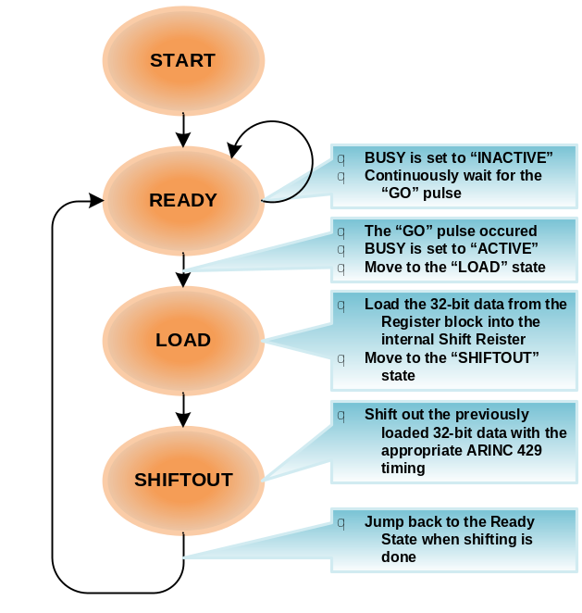

When a fault is detected, the PIC controller determines that a message needs to be sent. It internally construct the 32-bit ARINC 429 packet in four bytes and writes them out into the FPGA Registers. The Microcontroller then waits for the Busy signal (from the FPGA Shift Register block) to indicate a ready state (inactive). When the Busy signal indicates a “ready” state, the the controller writes to a dummy register to initiate the serial transfer.

3.3 Hardware Safety and Partitioning

The system is composed of diagnostics and other fail-safe mechanisms used to ensure that failures of the system are detected and that the system goes to a safe state if it's unable to perform a safety function. The hardware will be designed so that it will continue to operate, possibly at a reduced level, rather than failing completely, when some part of the system fails. During this condition, a visible fault indication will be present.

CERTIFICATION BASIS AND SAFETY CONSIDERATIONS
This section describes the certification basis, proposed means of compliance and the hardware design assurance level of each function of the hardware item. It also provides the justification for the hardware design assurance level assignment based on a safety assessment of the hardware and its use within the airborne system, including a description of potential hardware failure conditions. When applicable, either a summary of the FFPA or plan for performing an FFPA and applying the results should also be included.

Certification of the hardware has been accomplished as part of the lifecycle development. The Quality Assurance Engineer will compile applicable artifacts and submit them to the Certification Authority. Hardware verification objectives are satisfied through a combination of reviews and analysis, the development of test cases and procedures, and the subsequent execution of those test procedures. Reviews and analysis provide an assessment of the accuracy, completeness, and verifiability of the hardware requirements, hardware architecture and hardware.

The safety considerations include:

- Safety Assessment, including Fault Tree Analysis and Common Cause Analysis.
- Hardware’s life cycle process will meet the guidance of DO-254.
- Errors mitigation techniques – partitioning, redundancy, BIT – where employed to mitigate the hazards by architectural decisions.
- Monitoring Techniques, which enable an independent check of data, thus decreasing the probability of an undesired event to be undetected.

Certification Basis

The System Safety Assessment revealed that failure conditions which would prevent continued safe flight and landing. The applicable Failure Condition Category is Catastrophic. Hardware whose anomalous behavior would cause or contribute to a failure of system function resulting in a catastrophic failure condition for the aircraft is identified as Level A. Due to the FAA part 23 specific policy memo, the passenger counter has been developed to level B.

Function | System Failure | Criticality | Required Hardware Certification Level Per AC 2x.1309-1C
Function 01 | Failure 01 | Hazardous | B
Function 02 | Failure 02 | Minor | D
Function 03 | Failure 03 | Hazardous | B
Passenger count | Incorrect count | Catastrophic | A
Function 05 | Failure 05 | Hazardous | B
Function 06 | Failure 06 | Major | C
Function 07 | Failure 07 | Major | C
Function 08 | Failure 08 | Hazardous | B

The SSA determines the passenger count to be a catastrophic failure due to the airline needs for dispatch. The aircraft is a part 23 aircraft and will reduce this to level B based on FAA policy memo; Applying Advisory Circular 20-152, “RTCA, Inc., Document RTCA/DO-254, Design Assurance Guidance for Airborne Electronic Hardware,” to Title 14 Code of Federal Regulations, Part 23 Aircraft; PS-ACE100-2005-50001.

4.1.1 Hardware Design Assurance Levels

Hardware Unit | hardware Name | Design Assurance Level | Justification for Design Assurance Level
8 Bit Counter | FPGA | B | See Section 4.1.1
ARINC 429 I/O | FPGA | C | See Section 4.1.1

HARDWARE DESIGN LIFECYCLE
This section remains unchanged from the original PHAC and no deviations have been taken from the original design lifecycle approach.
This section describes the procedures, methods and standards to be applied and processes and activities to be performed to meet the hardware design assurance objectives. It describes the activities, combinations and sequencing of activities, relationships between processes and activities, transition criteria, responsibilities, tool usage, and means for providing feedback and interaction among hardware processes and between hardware processes and the system and software processes. This section may reference applicable plans, policies, standards, procedures and deviations to those plans and standards for the program.

The hardware Lifecycle includes the following processes as defined by the PHAC. The details of these processes have not been repeated here because there have been no modifications or deviations from these approved processes.

- Hardware Planning Process
- Hardware Development Process
- Requirements Capture Process.
- Hardware Conceptual Design Process.
- Hardware Detail Design Process.
- Hardware Implementation Process.
- Hardware Product Transition Process.

Integrated into and integral to each of these processes is the:

- Hardware Validation and Verification Process (See Section 5.1).
- Hardware Configuration Management Process (See Section 5.2).
- Process Assurance (See Section 5.3).
- Certification Liaison Process (See Section 5.4).

Hardware Validation and Verification Process

This section is repeated from the PHAC with no deviations and describes the validation process and the verification process. The full details of the verification and validation process id documented in the Hardware verification and validation plan (HVVP). The validation process provides assurance that the hardware item-derived requirements are correct and complete with respect to system requirements allocated to the hardware item. The verification process provides assurance that the hardware item implementation meets all of the hardware requirements, including derived requirements.

The released version of the Passenger Controller FPGAs has been run against the proposed final version of the hardware in order to collect validation and verification test results.

Objective
The Verification and Validation Plan describes the procedures, methods and standards to be applied and the processes and activities that have been conducted for the validation of the hardware item derived requirements to achieve the validation objectives of RTCA/DO-254. The HVVP includes validation and verification –methods, -data and –environment and organizational responsibilities.

Validation Methods
The validation activities that are conducted are analyses, tests, reviews and engineering judgments, with focus on reviews. Reviews are used as a qualitative method for evaluation of plans, requirements, design data, design concept and design implementation.

Verification Methods
To support level B certification of the Passenger Counter FPGAs, for HDL specified functions, coverage statistics are collected and recorded. Other verification activities that are conducted are tests, analyses, and reviews.

5.1.1 Technical Interfaces

The Project Engineer, Hardware Engineer, Hardware Configuration Management Engineer, Hardware process assurance Engineer and Systems and Equipment DER were involved in the Hardware Verification Process.

5.1.2 Transition Criteria

Transition criteria for the Hardware Verification Process were fully described in the Hardware Verification Plan.

Hardware Configuration Management Process

The configuration management process was intended to provide the ability to consistently replicate the configuration item, regenerate the information when necessary and modify the configuration item in a controlled fashion when modification was necessary. This section describes the objectives for hardware configuration management and activities that support those objectives.

Process Objectives and Activities

Objectives of the Configuration Management Process:

- Configuration items were uniquely identified and documented
- Consistent and accurate replication of configuration items was ensured
- A controlled method of identifying and tracking modification to configuration items was provided

Activities of the Configuration Management Process:

- Configuration items were uniquely identified, documented and controlled. This may have included, but was not limited to, hardware, design representations of hardware, tools or other data items used for certification credit and baselines
- Baselines were established
- Problems were uniquely identified, tracked and reported
- Change control and traceability of changes were maintained. This requires that life cycle data identified in the plans were secure and retrievable
- Archiving, retrieval and release of configuration items were controlled

Hardware Configuration Management is also responsible for:

- Hardware Configuration Management Records
- Problem Reports

Technical Interfaces

The Project Engineer, Hardware Engineer, Hardware Configuration Management Engineer, Hardware process assurance Engineer and Systems and Equipment DER were involved in the Hardware Configuration Management Process.

Transition Criteria

Transition criteria for the Hardware Configuration Management Process were fully described in the Hardware Configuration Management Plan.

Process Assurance Process

Process assurance ensures that the life cycle process objectives were met and activities have been completed as outlined in plans or that deviations have been addressed. This section describes the objectives for process assurance and the activities that supported those objectives. There was no intent to impose specific organizational structures.

Process Objectives and Activities

Objectives of the Process Assurance Process:

- Life cycle processes complied with the approved plans
- Hardware design life cycle data produced complied with the approved plans
- The hardware item used for conformance assessment is built to comply with the associated life cycle data

Activities of the Process Assurance Process:

- Availability of hardware plans as specified in the planning process section of this document and as agreed to in the PHAC were ensured
- Holding of reviews in compliance with the approved plans and tracking of resulting action items to closure were ensured
- Detection, recording, evaluation, approval, tracking and resolution of deviations from the hardware plans and standards were ensured
- Satisfaction of the transition criteria of the hardware life cycle processes in compliance with the approved plans were ensured
- An inspection was performed to ensure that the hardware item was built in compliance with its design data
- Records of the process assurance activities, including evidence of assessment of completion of design activities, were produced
- Where applicable, the applicant should ensure that the processes used by subcontractors were consistent with the hardware plans

Technical Interfaces

The Project Engineer, Hardware Engineer, Hardware Configuration Management Engineer, Hardware process assurance Engineer and Systems and Equipment DER were involved in the Process Assurance Process.

Transition Criteria

Transition criteria for the Process Assurance Process were fully described in the Hardware process assurance Plan.

Project Reviews

Hardware Conformity Review

The Hardware Conformity Review was held to obtain assurances that all Lifecycle processes were complete. The Hardware Quality Engineer conducted the review. The Hardware Quality Engineer assured that the Executable Object Code was controlled and can be regenerated. The Conformity Review Checklist was used during the review.

Certification Liaison Process

The purpose of the certification liaison process was to establish communication and understanding between the applicant and the certification authority throughout the hardware design life cycle to assist in the certification process. In addition, liaison activities may have included design approach presentation for timely approval, negotiation concerning the means of compliance with the certification basis, approval of design approach, means of data approval, and any required certification authority reviews and witnessing of tests.

Process Objectives and Activities

Objectives of the Certification Liaison Process:

- Resolved issues raised by the certification authority as a result of its reviews
- Submitted or made available other data or evidence of compliance requested by the certification authority

Activities of the Certification Liaison Process:

- The PHAC, hardware verification plan and other requested data were submitted to the certification authority for review at a point in time when the effects of design changes on the program were minimal
- Issues identified by the certification authority concerning the planning for the hardware aspects of certification were resolved
- Agreement on the PHAC was obtained with the certification authority
- Liaison with the certification authority during the design and certification cycle as outlined in the plan are continued and issues raised by the certification authority resolved in a timely manner

Technical Interfaces

The Project Engineer, Hardware Engineer, Hardware Configuration Management Engineer, Hardware process assurance Engineer and Systems and Equipment DER were involved in the Certification Liaison Process.

HARDWARE DESIGN LIFECYCLE DATA

This section describes the hardware design life cycle data items that have been produced during the hardware design life cycle for providing evidence of design assurance and compliance with certification requirements. The scope, amount and detail of the life cycle data needed by the certification authorities as design assurance evidence varied depending on a number of factors. These factors include the applicable certification authority requirements for the airborne system, the assigned design assurance levels, the complexity and the service experience of the hardware. Details of the design assurance evidence have been identified, recorded in the PHAC and agreed to with the certification authorities.
The descriptions of this section are not intended to imply a particular data packaging method, form or organization of the hardware life cycle data within a package. For example, all plans, standards, and procedures may be described in a single document or multiple documents.
Agreed-upon information and data where retrievable and available throughout the service life of the airborne system or equipment.

Hardware Lifecycle Data Produced and Controlled
In accordance with the assigned hardware control category per DO-254, the data in Table 6-1, has been created in the development of Passenger Counter system.

Hardware Design Life Cycle Data |  | DO-254 |  | Note 1  Submit |  | HW  Category |  | Data Items  Passenger Counter FPGA
Hardware Plans | 10.1
Plan for Hardware Aspect of Certification | 10.1.1 |  | S |  | HC1 |  | 800-PHAC-01 Rev A  (this document)
Hardware Design Plan (HDP) | 10.1.2 |  |  |  | HC2 |  | 800-PHAC-01 Rev A  (this document)
Hardware Validation Plan | 10.1.3 |  |  |  | HC2 |  | 800-HVVP-01 Rev A
Hardware Verification Plan | 10.1.4 |  | S |  | HC2 |  | 800-HVVP-01 Rev A
Hardware Configuration Management Plan | 10.1.5 |  |  |  | HC2 |  | 800-HCMP-01 Rev A
Hardware Process Assurance Plan | 10.1.6 |  |  |  | HC2 |  | 800-HPAP-01 Rev A
Hardware Design Standards | 10.2
Requirements Standards | 10.2.1 |  |  |  | HC2 |  | 800-HRS-01 Rev -
Hardware Design Standards | 10.2.2 |  |  |  | HC2 |  | 800-PHAC-01 Rev A  (this document)
Validation and Verification Standards | 10.2.3 |  |  |  | HC2 |  | 800-HVVP-01 Rev A
Hardware Archive Standards | 10.2.4 |  |  |  | HC2 |  | 800-HRD-01 Rev B
Hardware Design Data | 10.3
Hardware Requirements | 10.3.1 |  |  |  | HC1 |  | 800-HRD-01 Rev B
Hardware Design Representation Data | 10.3.2
Conceptual Design Data | 10.3.2.1 |  |  |  | HC2 |  | 800-HRD-01 Rev A
Detailed Design Data | 10.3.2.2
Top-level Drawing | 10.3.2.2.1 |  | S |  | HC1 |  | 800-HCI-01 Rev -
Assembly Drawings | 10.3.2.2.2 |  |  |  | HC1 |  | 800-HCI-01 Rev -
Installation Control Drawings | 10.3.2.2.3 |  |  |  | HC1 |  | 800-HCI-01 Rev -
Hardware/Software Interface Data | 10.3.2.2.4 |  |  |  | HC1 |  | 800-HRD-01 Rev A
Validation and Verification Data | 10.4
Hardware Traceability Data | 10.4.1 |  |  |  | HC2 |  | 800-HTR-01 Rev -
Hardware Review and Analysis Procedures | 10.4.2 |  |  |  | HC1 |  | 800-HTP-01 Rev A
Hardware Review and Analysis Results | 10.4.3 |  |  |  | HC2 |  | 800-HTR-01 Rev A
Hardware Verification Test Procedure | 10.4.4 |  |  |  | HC2 |  | 800-HTP-01 Rev A
Hardware Verification Test Results | 10.4.5 |  |  |  | HC2 |  | 800-HTR-01 Rev A
Problem Reports | 10.6 |  |  |  | HC2 |  | Part of web development PR system
Hardware Configuration Management Records | 10.7 |  |  |  | HC2 |  | Part of web development PR system
Hardware Process Assurance Records | 10.8 |  |  |  | HC2 |  | CCB records, Checklists, Review Minutes, Audit Reports
Hardware Accomplishment Summary | 10.9 |  | S |  | HC1 |  | 800-HAS-01 (this document)
Table 6-1 Passenger Counter FPGA Hardware Life Cycle Documents
Data that should be submitted is indicated by an S in the Submit column. HC1 and HC2 data used for certification need not be submitted but should be available. Refer to DO-254 Section 7.3

Hardware Design Life Cycle Data |  | DO-254 |  | Note 1  Submit |  | Hardware Category |  | Data Items  Arinc 429 I/O FPGA
Hardware Plans | 10.1
Plan for Hardware Aspect of Certification | 10.1.1 |  | S |  | HC1 |  | 800-PHAC-01 Rev A
Hardware Design Plan (HDP) | 10.1.2 |  |  |  | HC2 |  | 800-PHAC-01 Rev A
Hardware Validation Plan | 10.1.3 |  |  |  | HC2 |  | 800-HVVP-01 Rev A
Hardware Verification Plan | 10.1.4 |  | S |  | HC2 |  | 800-HVVP-01 Rev A
Hardware Configuration Management Plan | 10.1.5 |  |  |  | HC2 |  | 800-HCMP-01 Rev A
Hardware Process Assurance Plan | 10.1.6 |  |  |  | HC2 |  | 800-HPAP-01 Rev A
Hardware Design Standards | 10.2
Requirements Standards | 10.2.1 |  |  |  | HC2 |  | 800-HRS-01 Rev -
Hardware Design Standards | 10.2.2 |  |  |  | HC2 |  | 800-PHAC-01 Rev A
Validation and Verification Standards | 10.2.3 |  |  |  | HC2 |  | 800-HVVP-01 Rev A
Hardware Archive Standards | 10.2.4 |  |  |  | HC2 |  | 880-HRD-01 Rev B
Hardware Design Data | 10.3
Hardware Requirements | 10.3.1 |  |  |  | HC1 |  | 880-HRD-01 Rev B
Hardware Design Representation Data | 10.3.2
Conceptual Design Data | 10.3.2.1 |  |  |  | HC2 |  | 880-HRD-01 Rev A
Detailed Design Data | 10.3.2.2
Top-level Drawing | 10.3.2.2.1 |  | S |  | HC1 |  | 880-HCI-01 Rev -
Assembly Drawings | 10.3.2.2.2 |  |  |  | HC1 |  | 880-HCI-01 Rev -
Installation Control Drawings | 10.3.2.2.3 |  |  |  | HC1 |  | 880-HCI-01 Rev -
Hardware/Software Interface Data | 10.3.2.2.4 |  |  |  | HC1 |  | 880-HRD-01 Rev A
Validation and Verification Data | 10.4
Hardware Traceability Data | 10.4.1 |  |  |  | HC2 |  | 880-HTR-01 Rev -
Hardware Review and Analysis Procedures | 10.4.2 |  |  |  | HC1 |  | 880-HTP-01 Rev A
Hardware Review and Analysis Results | 10.4.3 |  |  |  | HC2 |  | 880-HTR-01 Rev A
Hardware Verification Test Procedure | 10.4.4 |  |  |  | HC2 |  | 880-HTP-01 Rev A
Hardware Verification Test Results | 10.4.5 |  |  |  | HC2 |  | 880-HTR-01 Rev A
Problem Reports | 10.6 |  |  |  | HC2 |  | Part of web development PR system
Hardware Configuration Management Records | 10.7 |  |  |  | HC2 |  | Part of web development PR system
Hardware Process Assurance Records | 10.8 |  |  |  | HC2 |  | CCB records, Checklists, Review Minutes, Audit Reports
Hardware Accomplishment Summary | 10.9 |  | S |  | HC1 |  | 800-HAS-01 (this document)
Table 6-2 Arinc 429 I/O FPGA Hardware Life Cycle Documents
Data that should be submitted is indicated by an S in the Submit column. HC1 and HC2 data used for certification need not be submitted but should be available. Refer to DO-254 Section 7.3

7.0 PREVIOUSLY DEVELOPED HARDWARE

7.1 ARINC 429 I/O FPGA

The ARINC 429 I/O FPGA provides for transmitting and receiving of ARINC 429 data. The FPGA consists of four independent ARINC receivers and one ARINC 429 transmitter. The Transceiver interfaces to a micro controller via an 8 bit bidirectional data bus, 4 address lines and 4 control lines. The device is programmable to accept either analog or digital signals. The receivers are programmable for speed selection and automatic label recognition. The aircraft interfaces served by the FPGA remain unchanged; therefore the speed settings and label programming remain the same.

The ARINC 429 I/O FPGA part C800-1010-00 is currently used on earlier versions of the Passenger Counter and other systems for ACMEY co and has been reused in this design with no changes. The original DAL for this device was DAL level C. The approved approach documented in the PHAC for retesting of the device in its new environment and assessment of DO-254 section 11.1 have been accomplished according to the plans with no deviations.

7.1.1 ARINC 429 I/O FPGA Re-verification

The configuration of this device has been documented as part of the Hardware Requirements Document for the passenger counter system and board level verification has been performed to demonstrate its correct operation in the passenger counter system. Hardware/ Software integration testing has also been performed to provide verification of this device in its new hardware environment. Traceability has been performed for the functions that this device performs to the system level requirements. All derived implementation has been analyzed and documented in the verification results document to see that there is no safety impact for unused functions of this device.

8.0 ADDITIONAL CONSIDERATIONS

This section describes the additional considerations. These include use of previously developed hardware, including references to applicable data reused, COTS usage, product service experience, and tool assessment and qualification or design assurance considerations for Level A or B functions.

8.1 Use of Commercial-Off-The-Shelf (COTS) Components

The use of COTS components have been verified through the overall design process, including the supporting processes, as defined in this document. The use of an electronic component management process, in conjunction with the design process, provides the basis for COTS component usage.

8.2 SH-1 Issue paper compliance

All the applicable aspects of the issue paper in accordance with the PHAC have been addressed. The sections below are repeated from the PHAC with no deviation.

Modifiable Devices

The devices used in this system are SRAM based and are loaded via a JTAG interface but only in the shop by the original manufacturer. Therefore the concerns related to Field-Loadable Hardware Logic, Option-Selectable Hardware Logic or User Modifiable Hardware Logic do not apply.

8.2.2 Certification Plan

A single PHAC (this document) have been generated to cover all ‘Programmed Electronic Hardware’.

8.2.3 Validation Processes

Validation is addressed by the Hardware Validation & Verification Plan document.

8.2.4 Verification Processes

Verification is addressed by the Hardware Validation & Verification Plan document.

8.2.5 Traceability

Traceability is addressed by the Hardware Validation & Verification Plan document.

8.2.6 Configuration Management

Configuration Index Documents are submitted in lieu of Top Level Drawings and will include the hardware design and verification environment.

8.2.7 Tool Assessment & Qualification

Not Applicable – Tool service history will not be used for credit. Each tool is checked by another tool or other independent means (section TBD refers).

8.2.8 Simple Electronic Hardware (SEH)

Not Applicable –both FPGAs have been treated as complex Programmed Electronic Hardware items for this program. Design assurance have been provided by a rigorous design life cycle rather than comprehensive testing.

8.2.9 Legacy Airborne Systems & Equipment Electronic Hardware

See section 7.2 above for previously developed FPGA usage.

8.2.10 Commercial Off-The-Shelf (COTS) Microprocessors

The PIC COTS Microprocessor have been used and the majority of the software testing have been performed on the target processor in order to verify the correct operation of this COTS device in its operating environment. A components management plan is in place at ACMEY CO for all COTS purchased parts to handle any revisions or modifications of this device by the manufacturer. The Errata for this device has been checked and there are no issues reported as of the date of this document.

8.2.11 Random Access Memory (RAM) based FPGAs

SRAM based FPGAs have been used in the system. Xilinx devices are SRAM based. An analysis of the operation and use of this system has been performed and due to the fact that is operated on the ground, there are very few atmospheric effects at this altitude. This has been reviewed by the system safety processes and the probability of failure on the ground is less than the 10-9 requirement for catastrophic systems, DAL A.

8.3 Development & Verification Tools

Development tools that require qualification are those tools whose output is part of airborne hardware and can introduce errors. All the tools used in the development and verification of the passenger counter system and the versions have been documented in the Hardware Configuration Index document 800-HCI-01 and 880-HCI-01.

9.0 ALTERNATIVE METHODS

This section describes any alternative methods proposed for the program, which are either not described in this document or are to be applied in a manner other than as described in this document. Justification for why the alternative method is acceptable should be provided. There have been no alternative methods used on this project.

10.0 CERTIFICATION

The following milestones were defined in the master schedule and provide the certification authority with the means to plan their project involvement. The table below summarizes those activities.

- Stages of Involvement #1: Planning Review
- Stages of Involvement #2: Development Review
- Stages of Involvement #3: Verification Review
- Stages of Involvement #4: Final Review

Stage Of Involvement Summary (SOIs)

Package | Date [1] | SOI # | Company/ Location | Audit Location | Actions/  Findings  (Open) | Obs
Passenger Counter FPGAs | 12-12-2009 | 1 | Subcontract_CO.; Hiptown, Texas  ACMEY Co,. Reno Nevada | On-site ACMEY Co. | 32(0) | 2
Passenger Counter FPGAs | 8-7-2010 | 2 | “ “ | On-site- at ACMEY Co. Reno Nevada | 15(0) | 3
Passenger Counter FPGAs | 9-10-2010 | 3 | “ “ | Desk Review/Webex | -5(0) | 2
Passenger Counter FPGAs | 2-11-2011 | 4 | “ “ | Desk Review/Webex | 2(0) | 1

11.0 HARDWARE IDENTIFICATION

The following hardware was produced.

Part Number Identification

Part Number | Nomenclature
S800-1000-01 | Avionics Passenger Counter
C800-1001-01 | Passenger Counter FPGA, 8 Bit Counter
C800-1010-00 | ARINC 429 I/o FPGA

12.0 CHANGE HISTORY

This section identifies previous software releases and change summaries. Hardware changes are further identified in the Change Impact Analysis. The Change Impact Analysis follows the process defined in FAA Order 8110.49 and DO-254 section 11 (previously developed hardware). This process was used to determine the potential impact of the change on continued operational safety of the aircraft.

The analysis also provided a basis for determining the extent of certification authority involvement. If the change was determined to be Minor, certification authority involvement has been relatively minimal; however, if the change was determined to be Major, certification authority involvement and oversight was increased.

12.1 Hardware Change History

See Hardware Configuration Index for a complete revision history.

13.0 HARDWARE STATUS- Open PRs

This section contains a list of problem reports unresolved at the time of certification. No problems that remain open have been determined to effect the safety or compliance to CFR xx.1301 and xx.1309.

Compliance Statement

ACMEY Co. complies with RTCA/DO-254, AC 20-152 and SH-1 issue paper.

14.1 Statement of Compliance with the PHAC

ACMEY Co. complies with the PHAC Passenger Counter System by using exactly the same hardware architecture in the Passenger Counter system project as described in Section 3 in the PHAC. ACMEY Co. also uses the fault tolerant mechanisms described in Section 3.4 in the PHAC for the real hardware.

For complex electronic hardware ACMEY Co. follows all certification considerations as described in the PHAC Section 4. There are no deviations between the functions performed by the real physical complex digital devices in the Passenger Counter System and the ones stated in section 3.0 in the PHAC. ACMEY Co. also follows all additional considerations as stated in Section 7 in the PHAC. Along with that ACMEY Co. follows the hardware design life cycle described in Section 5 in the PHAC. Finally, as evidence of compliance, ACMEY Co. has produced all documents described in Table 6-1 and 6-2 in this document which is a revised version of Table 6-1 and 6-2 from the PHAC.

